Madonna singles

Find twenty Madonna song titles in this puzzle

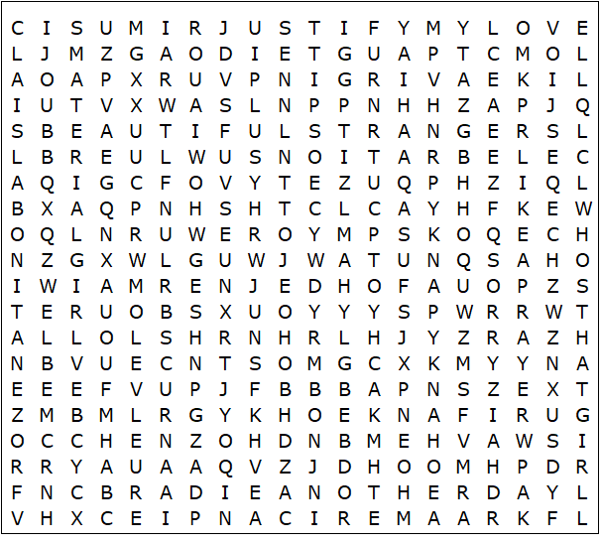

Madonna singles – Solution

American Pie  Beautiful Stranger  Celebration  Crazy for You  Die Another Day  Frozen  Hanky Panky  Hung Up  Into the Groove  Justify My Love | La Isla Bonita  Like a Prayer  Like a Virgin  Material Girl  Music  Papa Don't Preach  Sorry  True Blue  Vogue  Who's That Girl

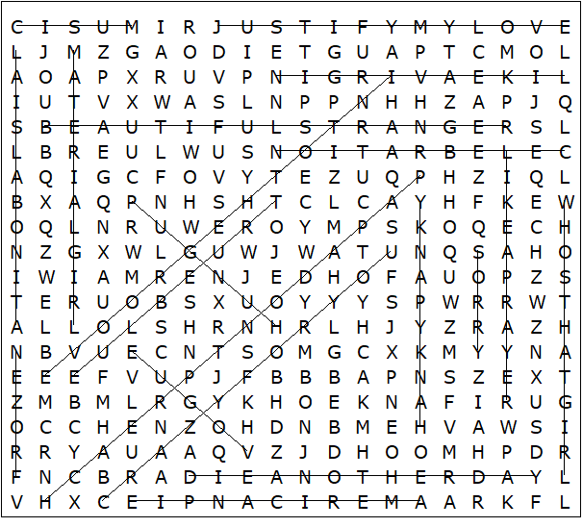

This worksheet was made up using TOOLBOX by Discovery Educational Software.

